Orian, John Richard ITWM106

M065

Prelim Exam

* Figma whole screenshot

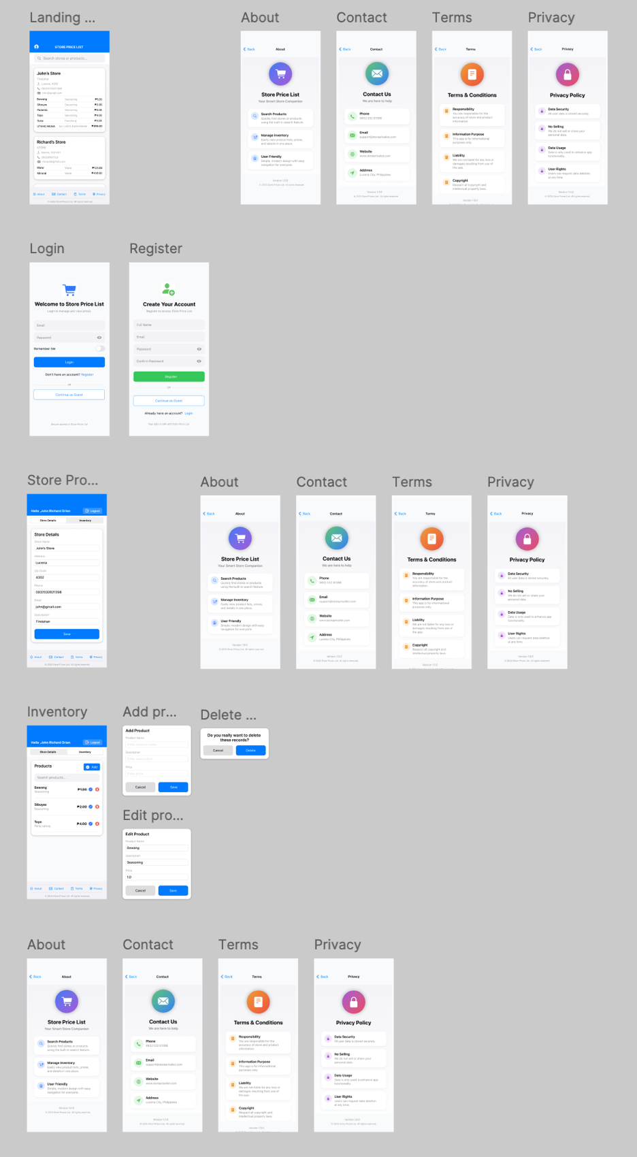

* Figma prototype with wireframe

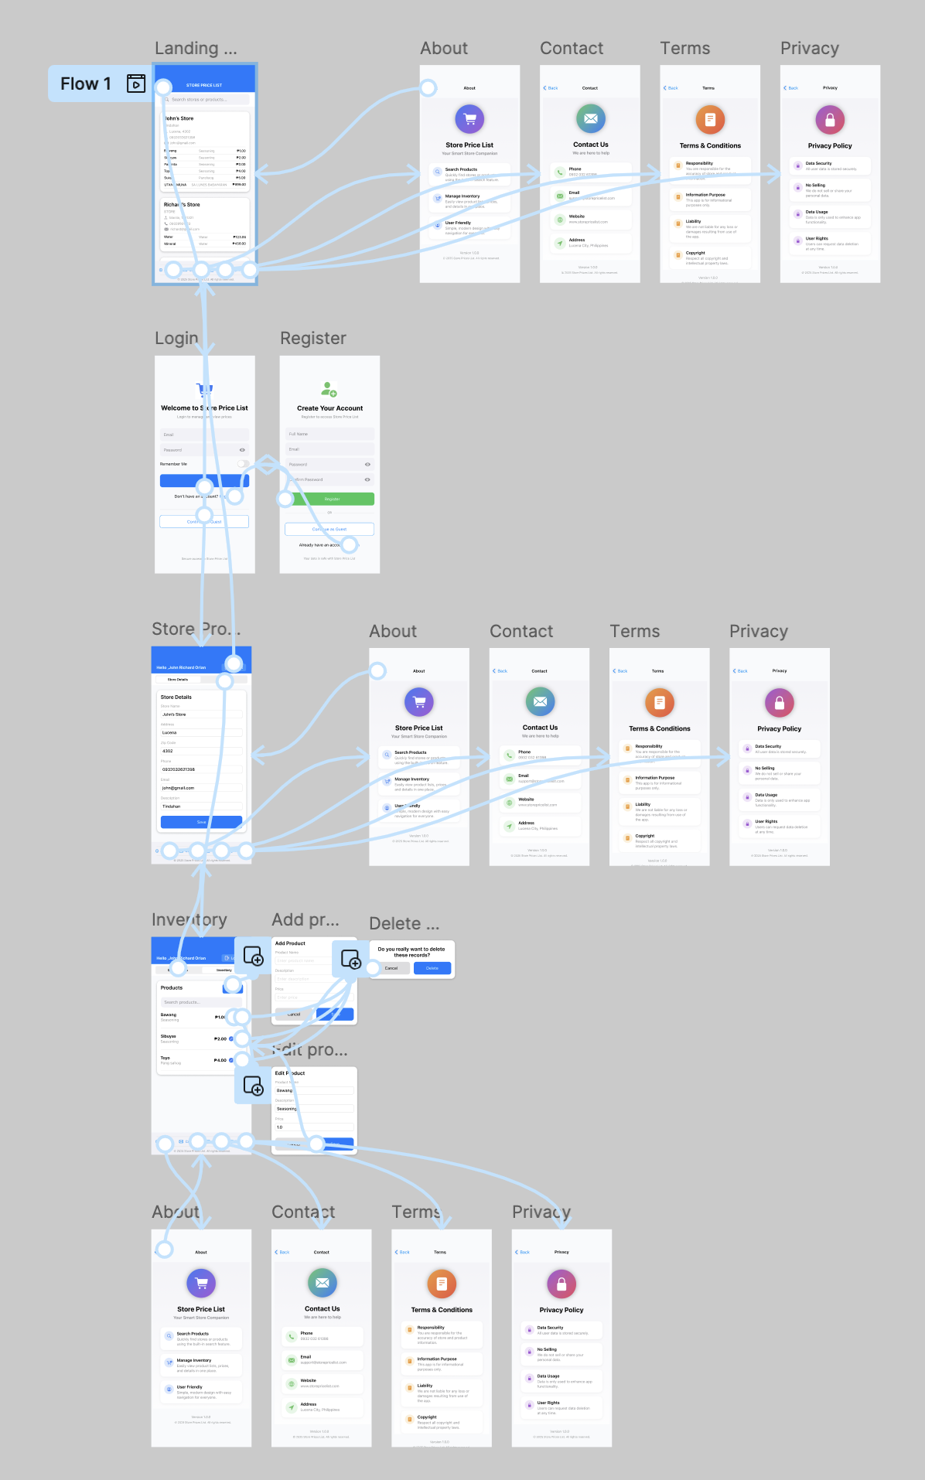

Figma Prototype (Specific)

1. Landing Page

When the user goes in mobile app, this the first screen they see. And without account they possible to use like as Guest Account. They can search the items to view the price of products in different stores. It included the About, Contact, Terms, and Privacy to know what the benefit for users is.

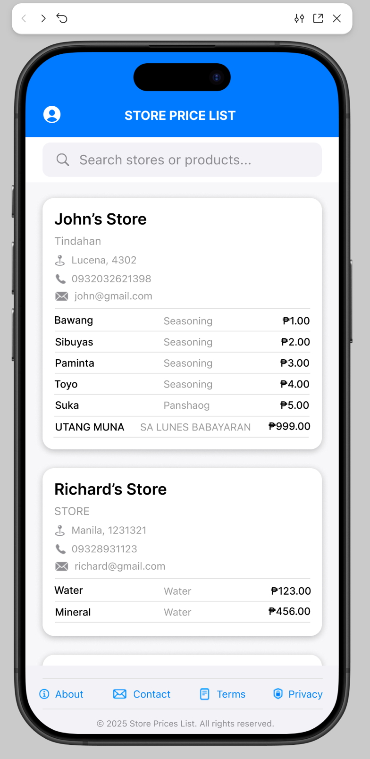

1. About Page

When the user clicks the About button page in footer, they redirect to About page that contain information what can get in Store Price List, like Search Products, Manage Inventory, and User Friendly.

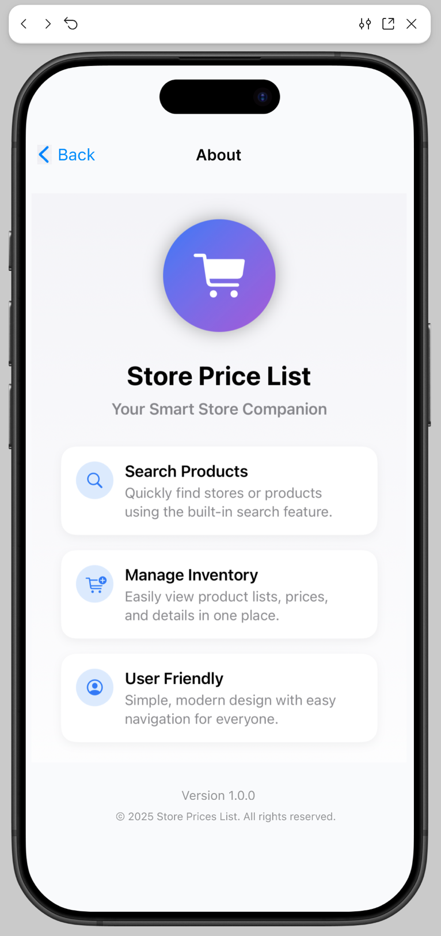

1. Contact

When the user clicks the Contact button in Footer, they can see what the contacts for developers is.

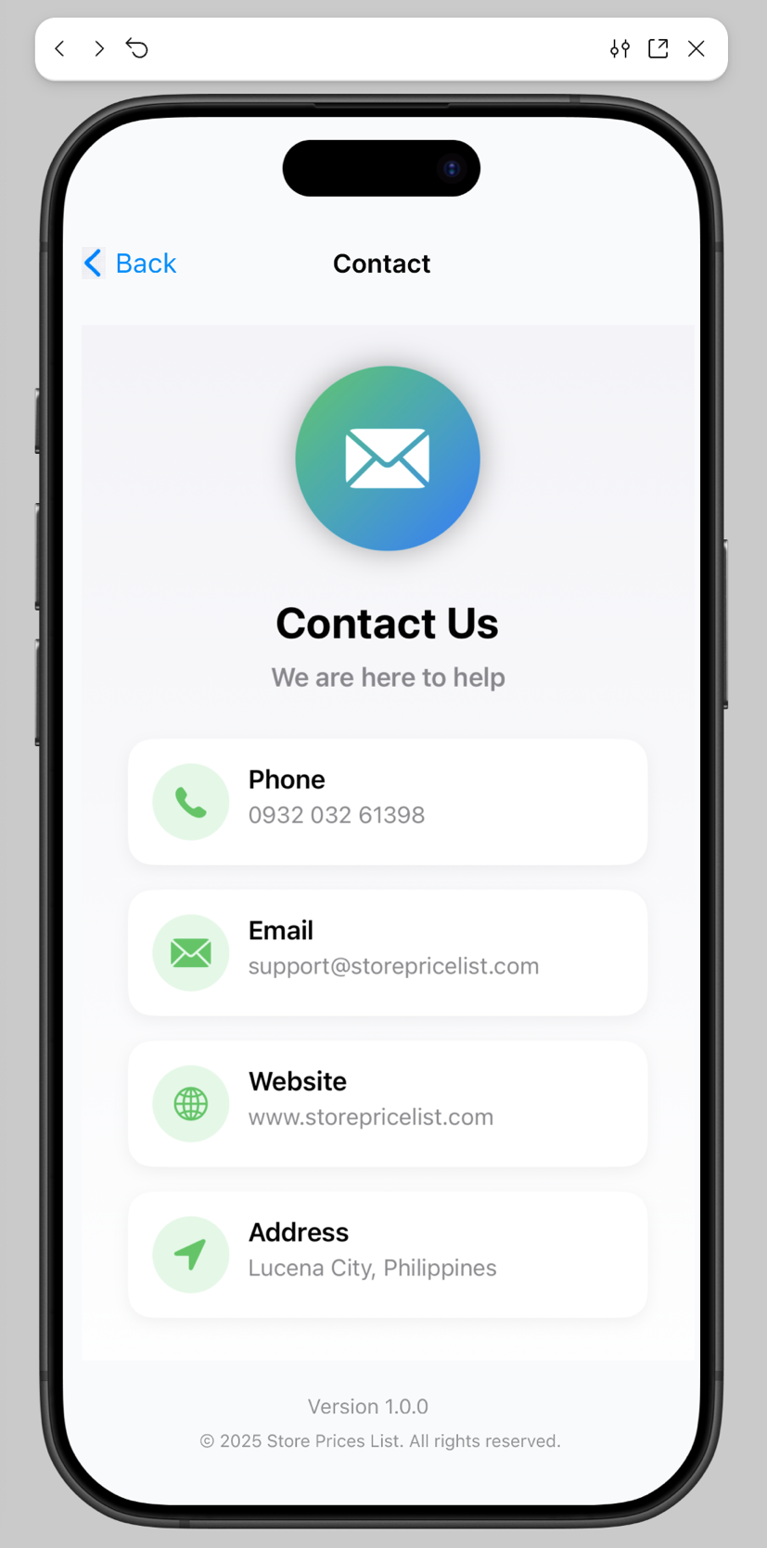

1. Terms and Conditions

When the user clicks the Terms button in Footer, they can see about Responsibility, Information Purpose, Liability, and Copyright about on Store Price List.

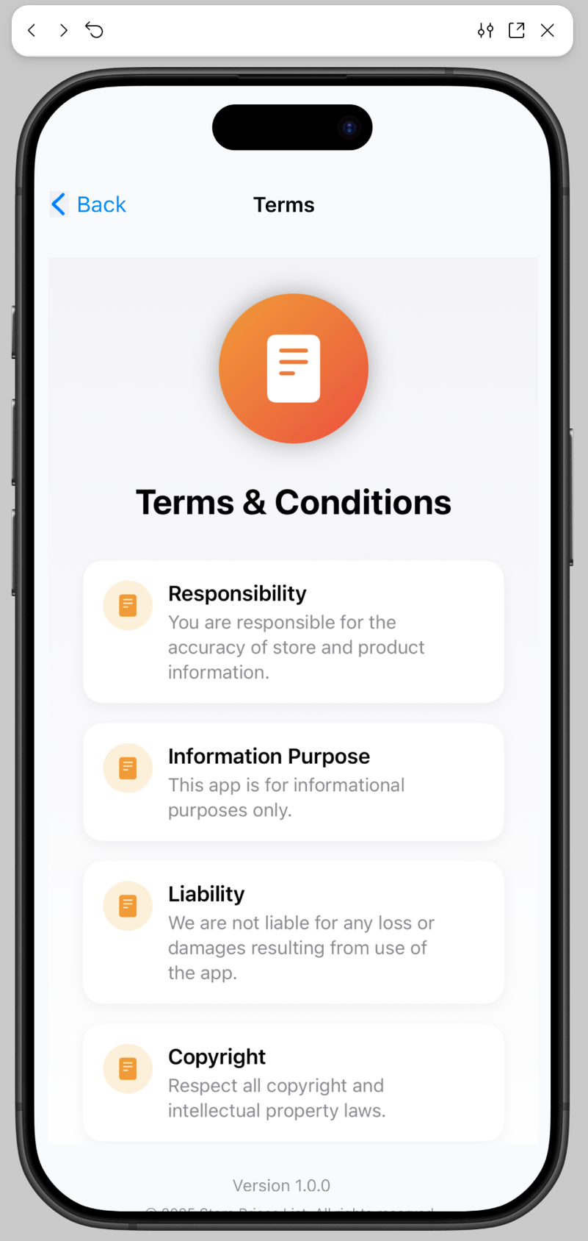

1. Privacy

When the user click the Privacy button in Footer in Landing Page, they see about on Data Security, No Selling, Data Usage, User Rights.

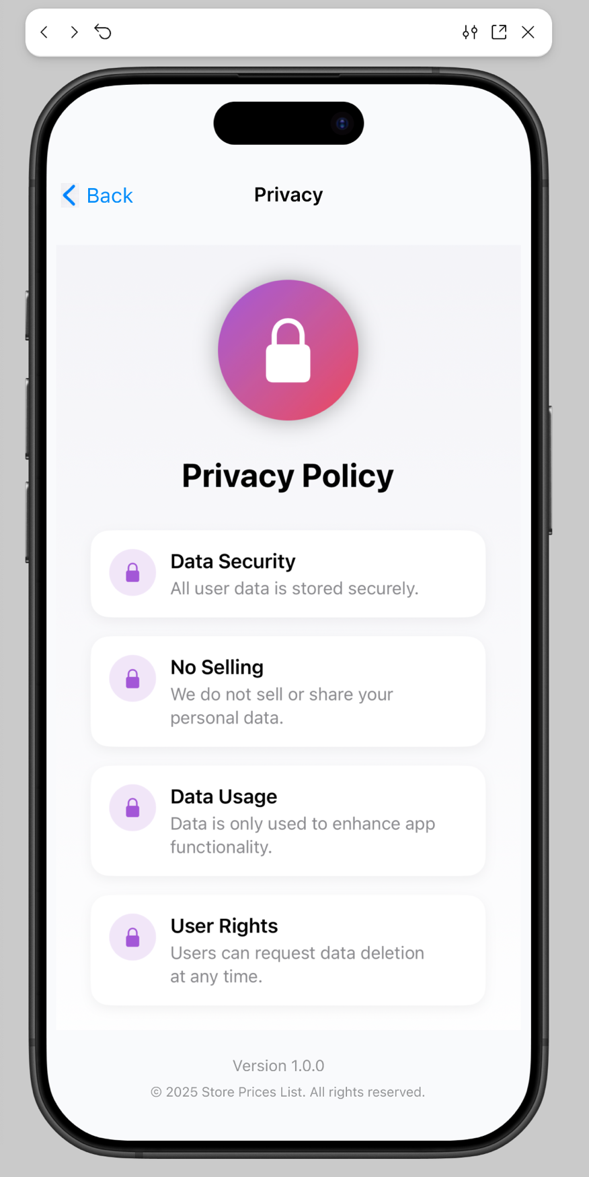

1. Login Page

When the user clicks the profile icon in Landing Page, they will go to Login Page. It will get the email and password. And have button for Continue as Guest. Or redirect for creating a new account.

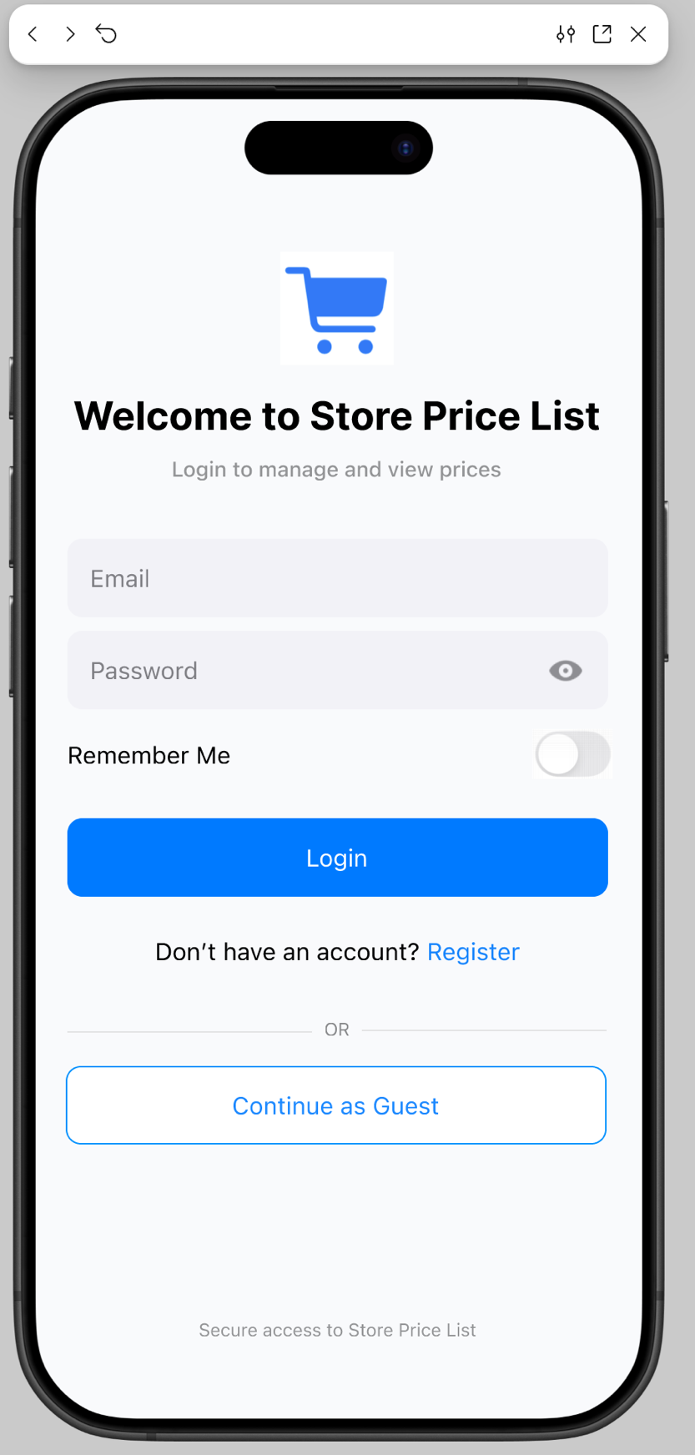

1. Register Page

This page is for creating account that will get the Full Name, Email, Password and Confirm Password. And redirect button for Continue as Guest or for Login Account.

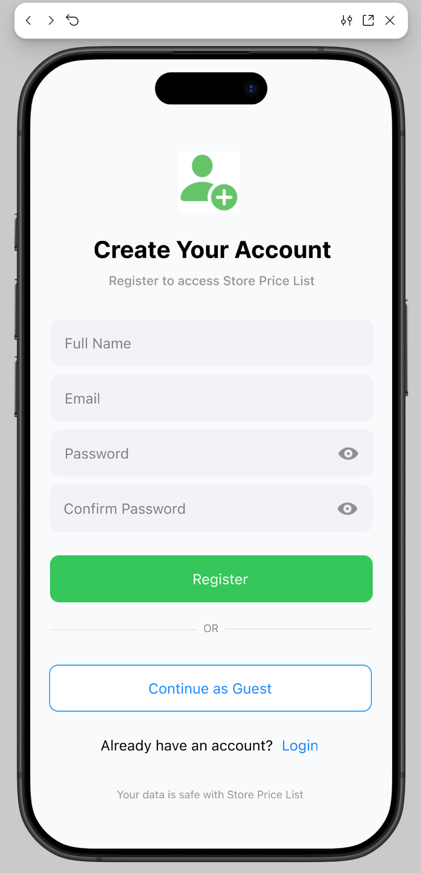

1. Store Profile Details Page

When the user login his/her accounts, they go in page below, they required to store her details about on his/her store like Store Name, Address, Zip Code, Phone Number, Email, and Description. And have logout button.

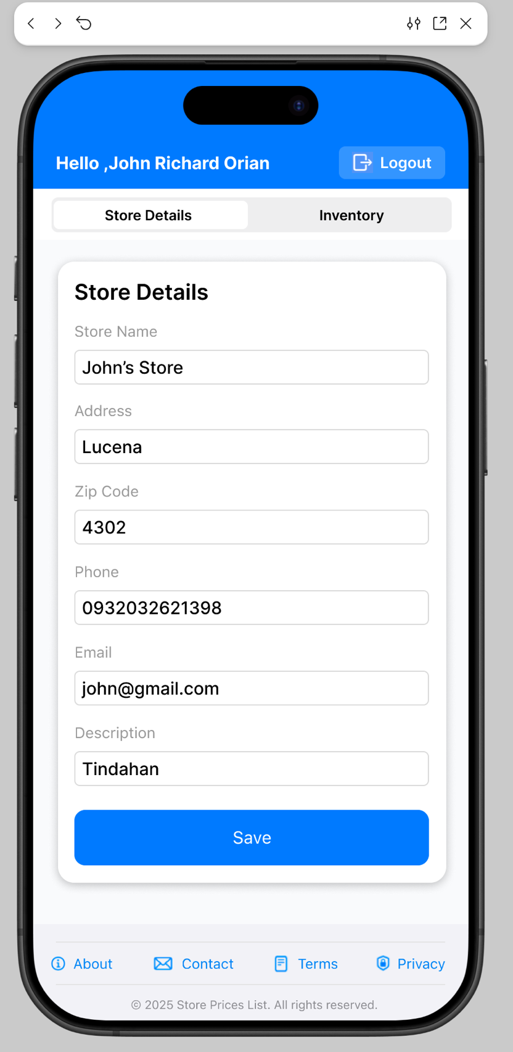

1. Inventory Page

The store owner or user can be able to add records for products and authorize to Edit and Delete these records.

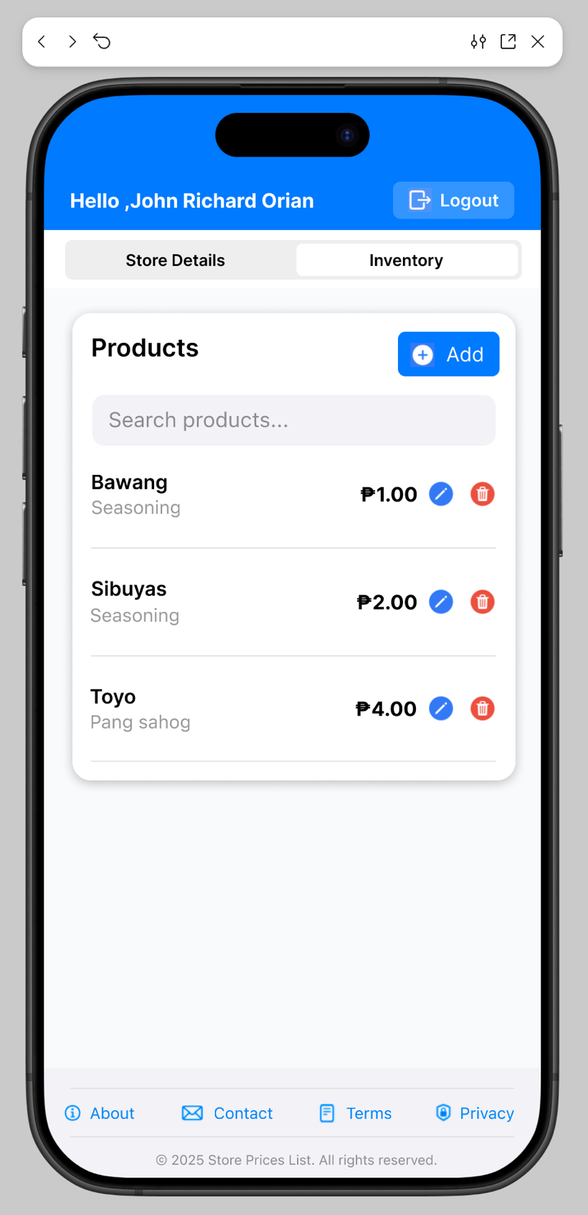

1. Add Product Modal

When the user click “Add” Button in “Inventory Page”, the add modal will pop up. For filling up the records. User able to Cancel and Save the da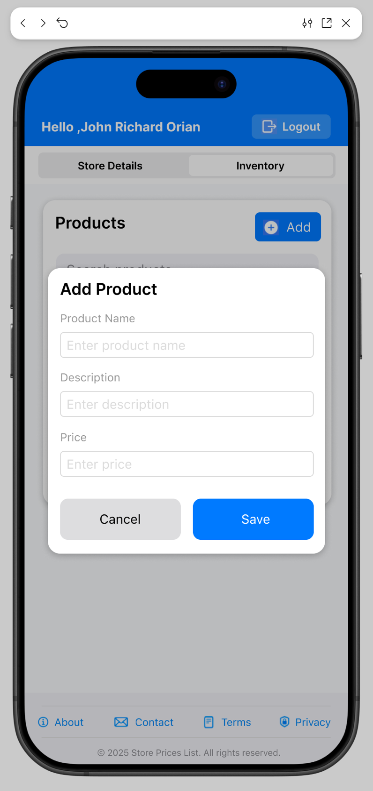

1. Edit Product Modal

When the user clicks the Edit button inside Inventory Page and selects the specific product. User can be able to edit the details in specific records or cancel it.

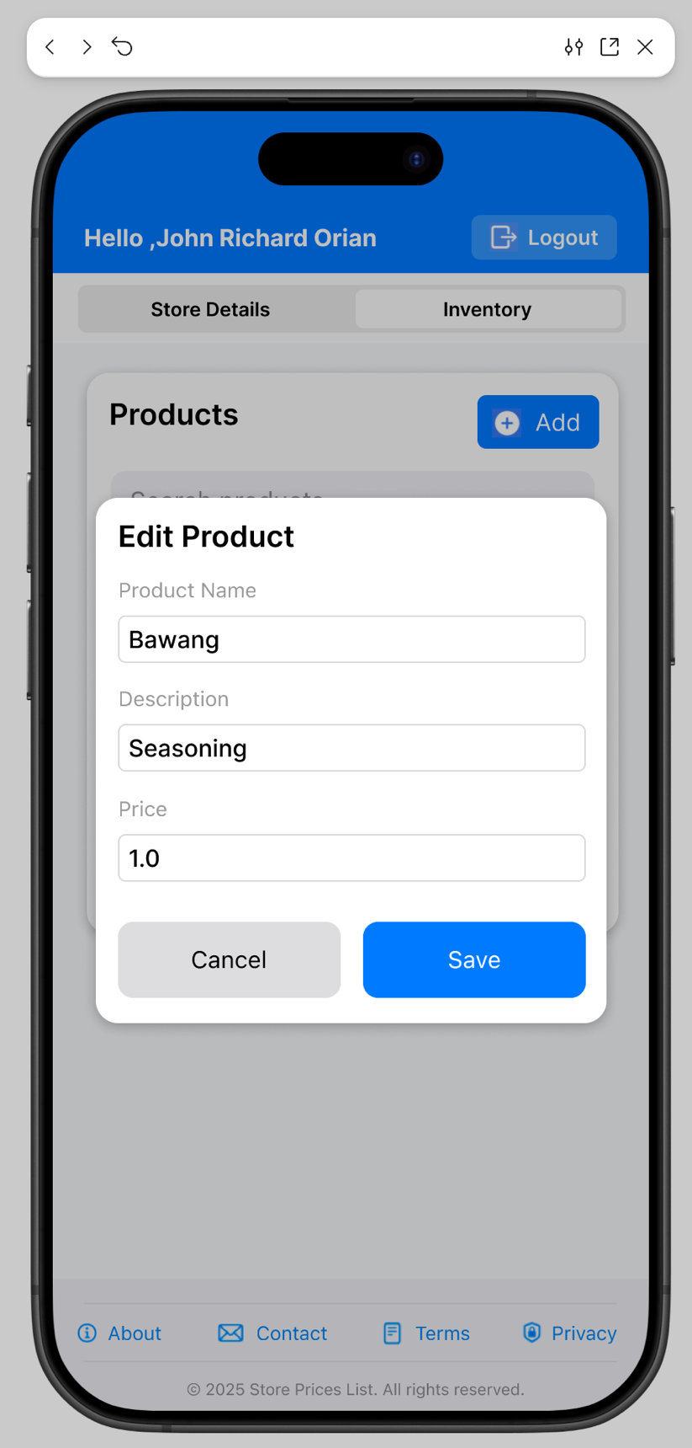

Xcode Functional UI

1. Folder Structure

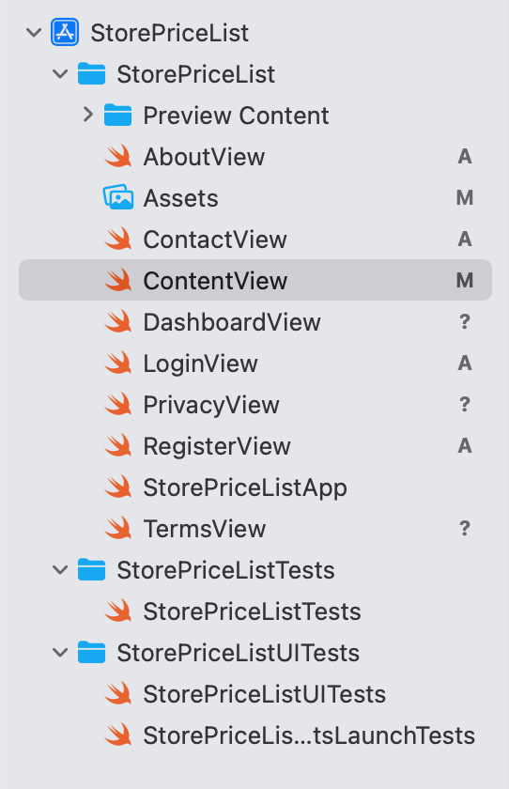

1. Landing Page

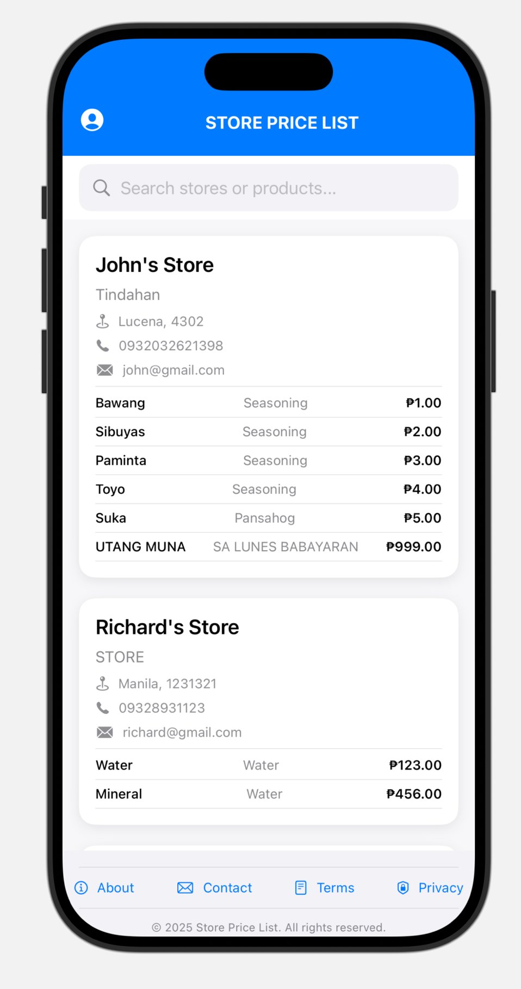

Static Data Code in Landing Page

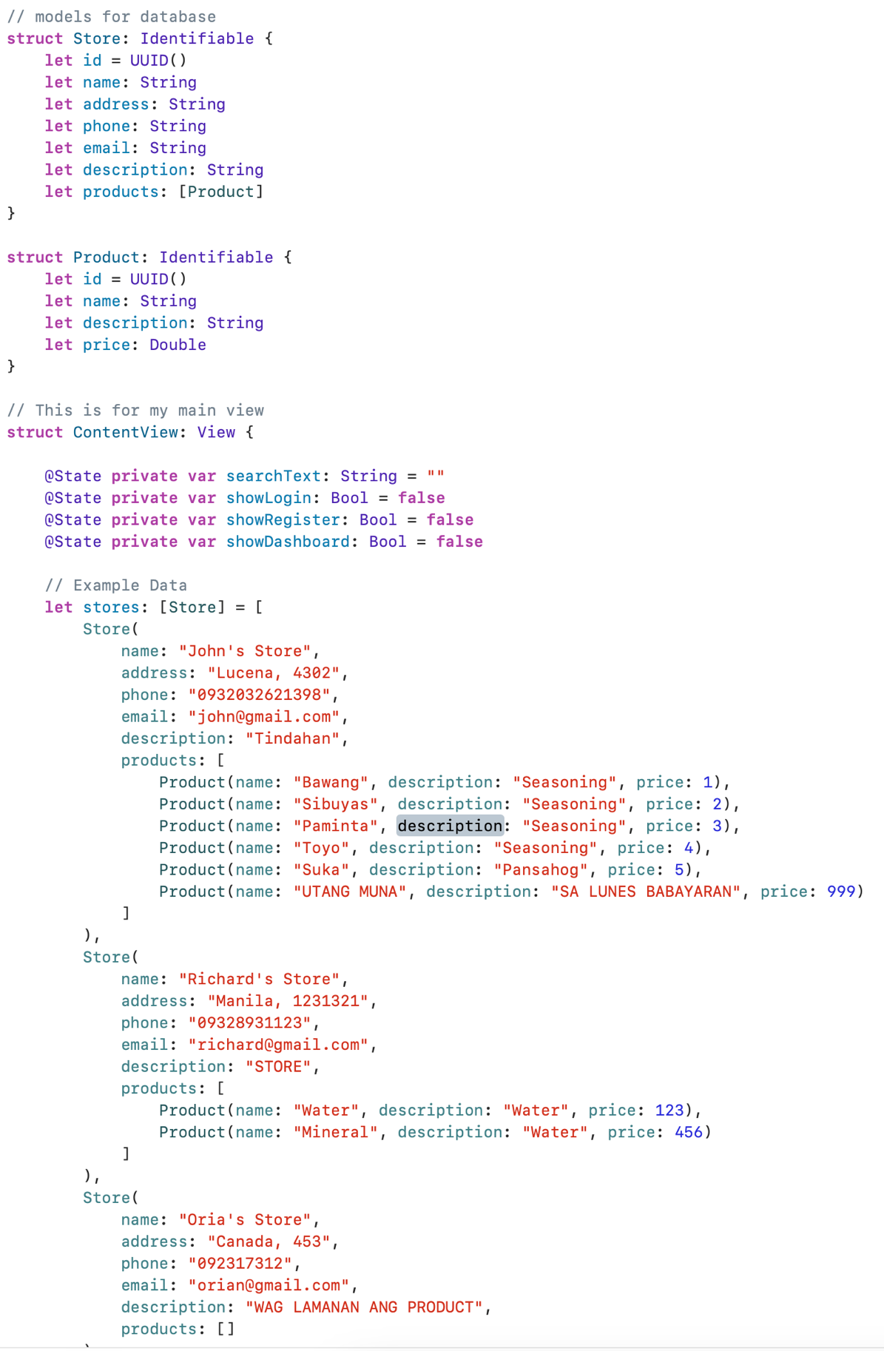

Footer Code in Landing Page

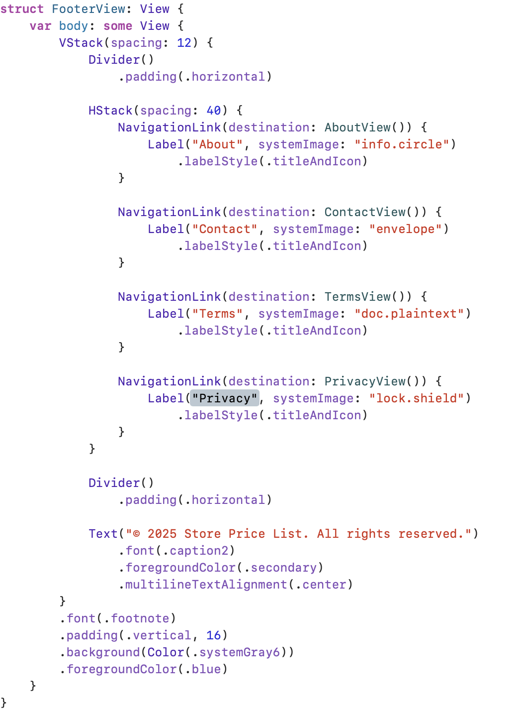

1. Login Page

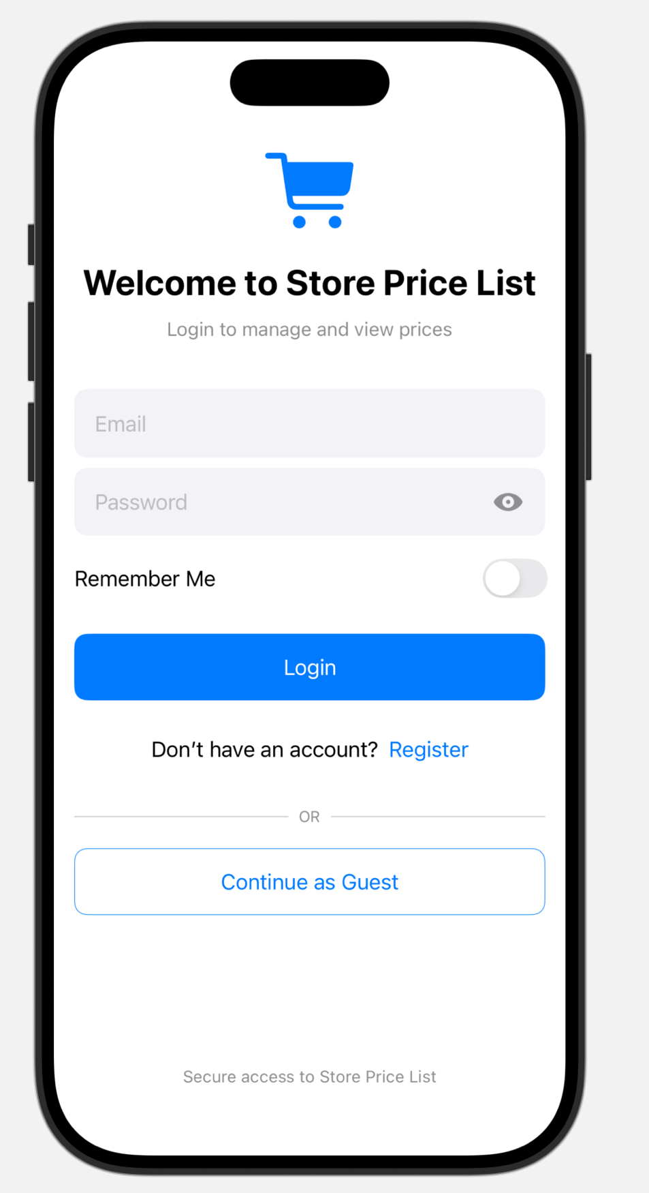

Get Information Code for Login

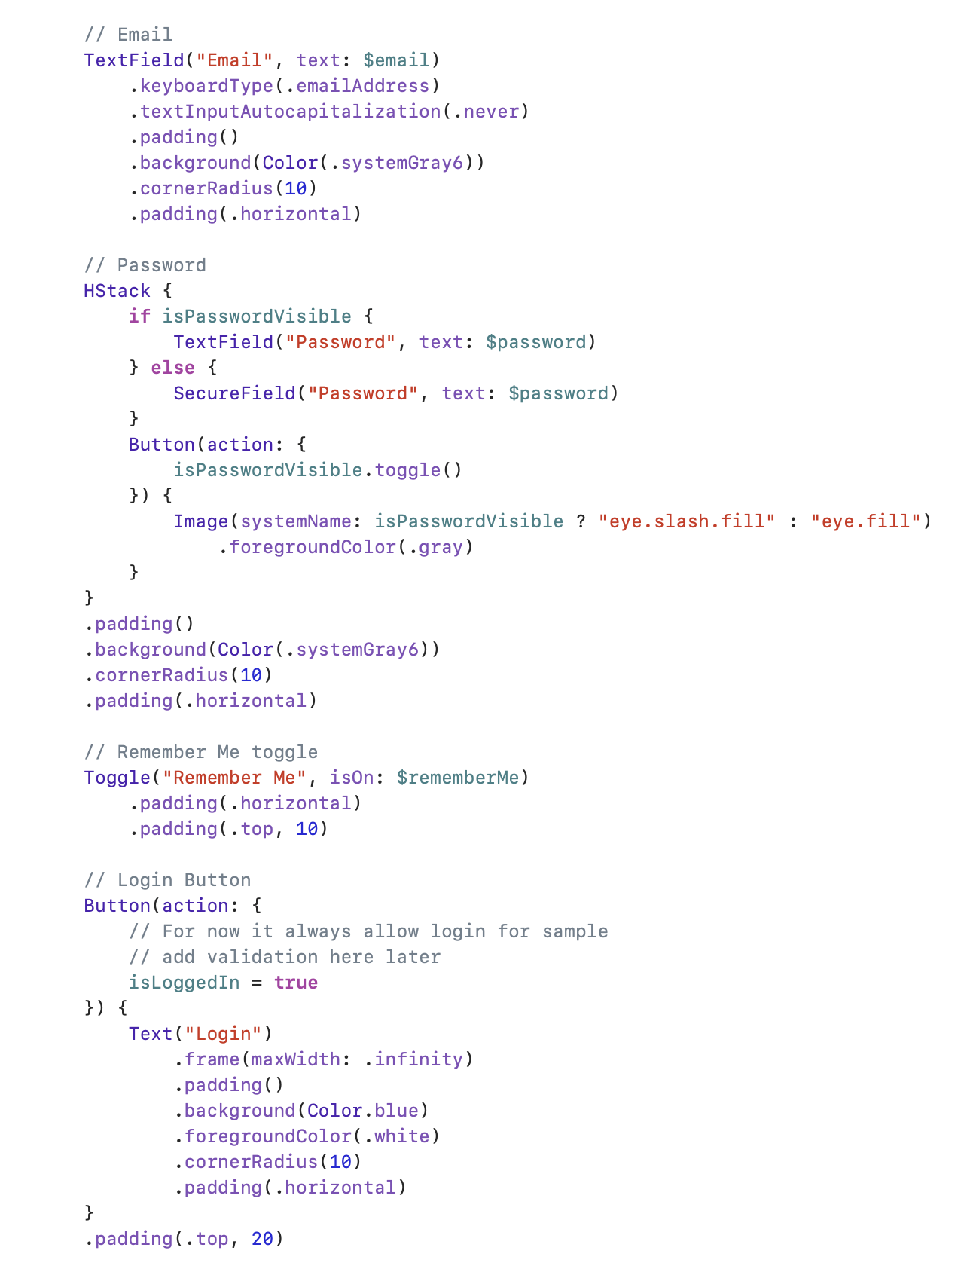

Continue as Guest Code

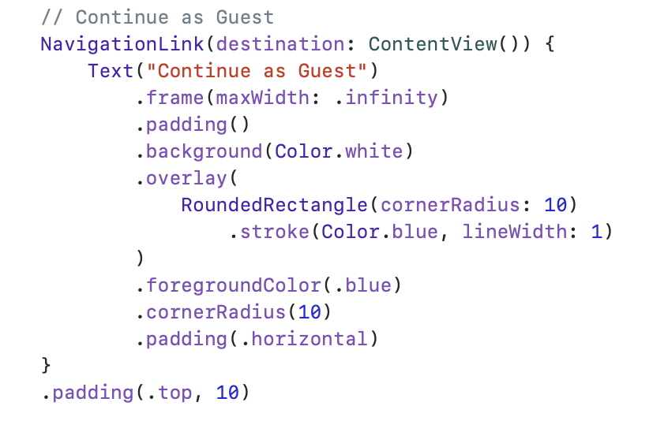

1. Register Page

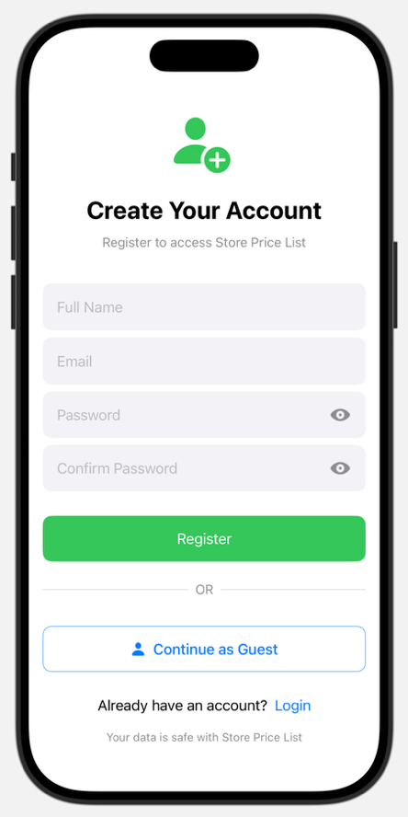

Register Code for Fill Up Forms

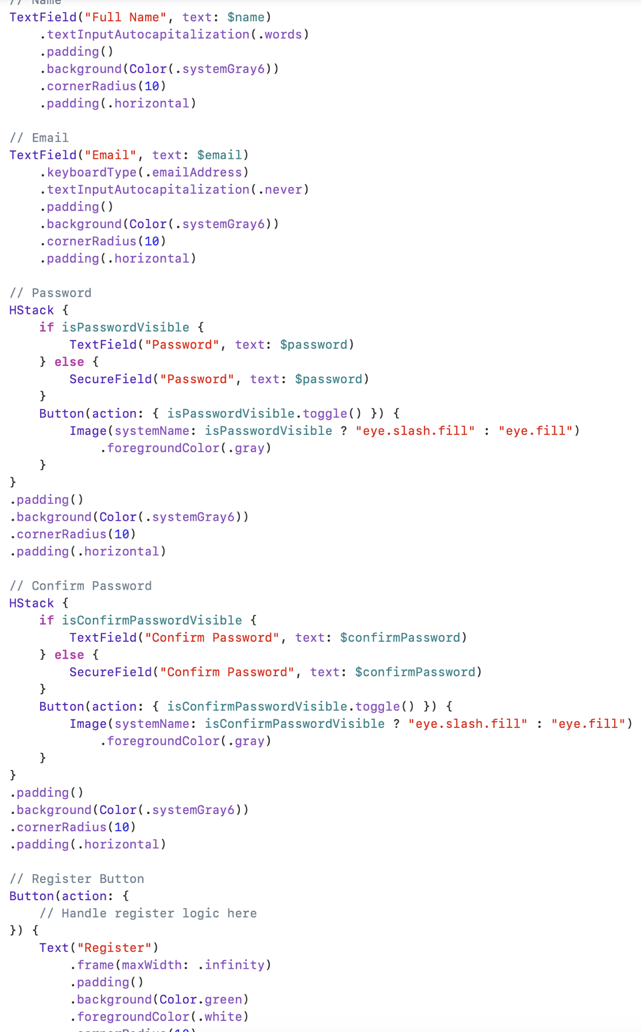

* Figma Link - <https://www.figma.com/design/yN1U9siyAruTECIIwSsgaE/Store-Price-List?node-id=0-1&t=eAeKvM4l0ImUfmUa-1>
* Figma Prototype Link - <https://www.figma.com/proto/yN1U9siyAruTECIIwSsgaE/Store-Price-List?node-id=0-1&t=eAeKvM4l0ImUfmUa-1>